Experiment Details

|  |  |
| --- | --- |
| Department Name | Civil and Environmental Engineering |
| Class | Second year |
| Semester | Third |
| Subject Name | Strength of Material Laboratory |
| Experiment No. | 01 |
| Experiment Name | Study of Universal Testing Machine |

Version History

|  |  |  |  |  |
| --- | --- | --- | --- | --- |
| Sr. No. | Version Number | Created By | Approved By | Date |
| 1 | v1.1 | Saie Dhavale | Sourabh Joshi | 27/10/2020 |
|  |  |  |  |  |

AIM:

Study of Universal Testing Machine (U.T.M.)

THEORY:

To Study the various component parts of the Universal Testing Machine (U.T.M.) & test procedures of various practical have to be performed The Universal Testing Machine consists of two units.

1) Loading unit, 2) Control panel

**LOADING UNIT: -**

It consists of main hydraulic cylinder with robust base inside. The piston which moves up and down. The chain driven by electric motor which is fitted on left hand side. The screw column maintained in the base can be rotated using above arrangement of chain. Each column passes through the main nut which is fitted in the lower cross head. The lower table connected to main piston through a ball & the ball seat is joined to ensure axial loading. There is a connection between lower table and upper head assembly that moves up and down with main piston. The measurement of this assembly is carried out by number of bearings which slides over the columns. The test specimen is fixed in the job is known as ‘Jack Job’. To fix up the specimen tightly, the movement of jack job is achieved helically by handle.

**CONTROL PANEL:-**

It consists of oil tank having a hydraulic oil level sight glass for checking the oil level. The pump is displacement type piston pump having free plungers those ensure for continuation of high pressure. The pump is fixed to the tank from bottom. The suction & delivery valve are fitted to the pump near tank Electric motor driven the pump is mounted on four studs which is fitted on the right side of the tank. There is an arrangement for loosing or tightening of the valve. The four valves on control panel control the oil stroke in the hydraulic system. The loading system works as described below. The return valve is close, oil delivered by the pump through the flow control valves to the cylinder & the piston goes up. Pressure starts developing & either the specimen breaks or the load having maximum value is controlled with the base dynameters consisting in a cylinder in which the piston reciprocates. The switches have upper and lower push at the control panel for the downward & upward movement of the movable head. The on & off switch provided on the control panel & the pilot lamp shows the transmission of main supply.

METHOD OF TESTING:-

Initial Adjustment: - Before testing adjust the pendulum with respect to

capacity of the test i.e. 8 Tones; 10 Tones; 20 Tones; 40 Tones etc. For ex: - A

specimen of 6 tones capacity gives more accurate result of 10 Tones capacity

range instead of 20 Tones capacity range. These ranges of capacity are

adjusted on the dial with the help of range selector knob. The control weights

of the pendulum are adjusted correctly. The ink should be inserted in pen

holder of recording paper around the drum & the testing process is started

depending upon the types of test as mentioned below.

TENSION TEST:-

Select the proper job and complete upper and lower check adjustment. Apply some Greece to the tapered surface of specimen or groove. Then operate the uppercross head grip operation handle & grip the upper end of test specimen fully in to the groove. Keep the lower left valve in fully close position. Open the right valve & close it after lower table is slightly lifted. Adjust the lower points to zero with the help of adjusting knob. This is necessary to remove the dead weight of the lower table. Then lock the jobs in this position by operating job working handle. Then open the left control valve. The printer on dial gauge at which the specimen breaks slightly return back & corresponding load is known as breaking load & maximum load is known as the ultimate load.

COMPRESSION TEST:-

Fix upper and lower pressure plates to the upper stationary head & lower table respectively. Place the specimen on the lower plate in order to grip. Then adjust zero by lifting the lower table. Then perform the test in the same manner as described in tension test.

FLEXURAL OR BENDING TEST:-

Keep the bending table on the lower table in such a way that the central position of the bending table is fixed in the central location value of the lower table. The bending supports are adjusted to required distance. Stuffers at the back of the bending table at different positions. Then place the specimen on bending table & apply the load by bending attachment at the upper stationary head. Then perform the test in the same manner as described in tension test.

BRINELL HARDNESS TEST:-

Place the specimen on the lower table & lift it up slightly. Adjust the zero fixed value at the bottom side of the lower cross head. Increase the load slowly ultimate load value is obtained. Then release the load slowly with left control valve. Get the impression of a suitable value of five to ten millimeter on the specimen & measure the diameter of the impression correctly by microscope & calculate Brinell hardness.

SHEAR TEST:-

Place the shear test attachment on the lower table, this attachment consists of cutter. The specimen is inserted in roles of shear test attachment & lift the lower table so that the zero is adjusted, then apply the load such that the specimen breaks in two or three pieces. If the specimen breaks in two pieces then it will be in angle shear, & if it breaks in three pieces then it will be in double shear.

STUDY OF EXTENSOMETER:-

This instrument is an attachment to Universal / Tensile Testing Machines. This measures the elongation of a test place on load for the set gauge length. The least count of measurement being 0.01 mm and maximum elongation measurement up to 3 mm. This elongation measurement helps in finding out the proof stress at the required percentage elongation.

WORKING OF THE INSTRUMENT:-

The required gauge length(between 30 to 120 ) is set by adjusting the upper knife edges ( 3 ) A scale ( 2 ) is provided for this purpose . Hold the specimen in the upper and lower jaws of Tensile / Universal Testing Machine. Position the extensometer on the specimen. Position upper clamp (4) To press upper knife edges on the specimen. The extensometer will be now fixed to the specimen by spring pressure. Set zero on both the dial gauges by zero adjust screws (7). Start loading the specimen and take the reading of load on the machine at required elongation or the elongation at required load. Force setter accuracies mean of both the dial gauge (8) readings should be taken as elongation. It is very important to note & follow the practice of removing the extensometer from the specimen before the specimen breaks otherwise the instrument will be totally damaged. As a safety, while testing the instrument may be kept hanging from a fixed support by a slightly loose thread.

TECHNICAL DATA:-

Measuring Range: 0 – 3 mm

Least Count: 0. 01 mm

Gauge Length adjustable from: 30 - 120 mm

Specimen Size: 1 to 20 mm Round or Flats up to 20 x 20 mm

1. 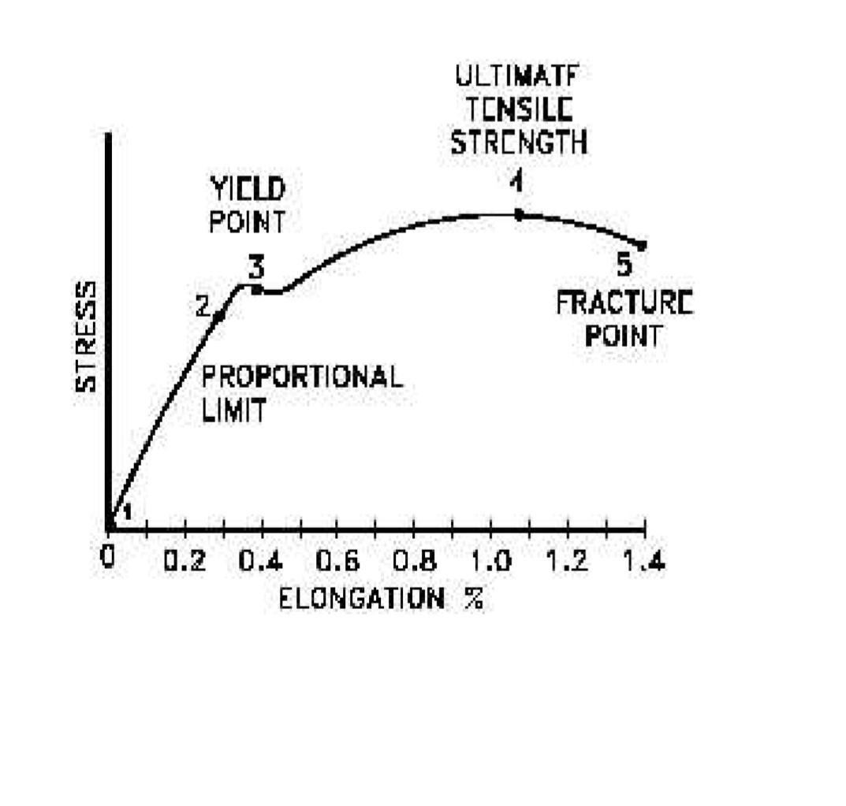Stress-strain graph for Mild Steel
2. 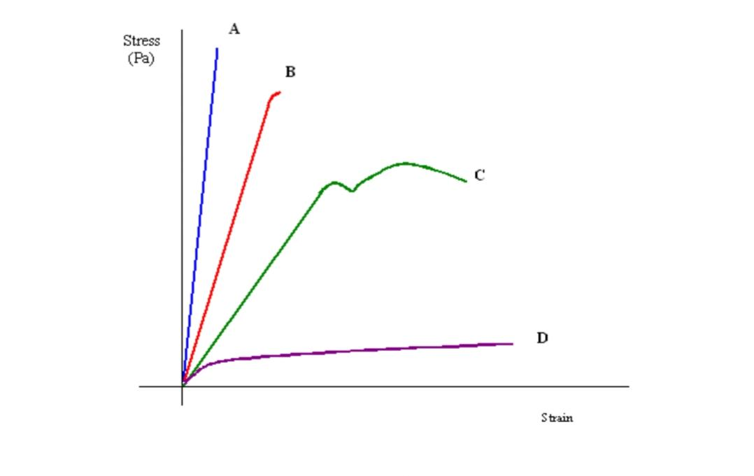Stress-strain graph for Different materials

• Curve A shows a brittle material. This material is also strong because there is little strain for a high stress. The fracture of a brittle material is sudden and catastrophic, with little or no plastic deformation. Brittle materials crack under tension and the stress increases around the cracks. Cracks propagate less under compression. • Curve B is a strong material which is not ductile. Steel wires stretch very little, and break suddenly. There can be a lot of elastic strain energy in a steel wire under tension and it will “whiplash” if it breaks. The ends are razor sharp and such a failure is very dangerous indeed. • Curve C is a ductile material Curve D is a plastic material. Notice a very large strain for a small stress. The material will not go back to its original length.

APPARATUS: Universal Testing Machine with all attachment i.e. shear test attachment, bending attachment, tension grips, compression test attachment etc.

PRE TEST:

1. Which of the following property cannot be determined by a tensile test?

**a) Yield strain**

b) Yield stress

c) Elastic limit

d) Limit of proportionality

2.Which type of load is applied in tensile testing?

**a) Axial load**

b) Shear load

c) Transverse load

d) Longitudinal load

3.Which of the following does not affect the value of ultimate tensile strength?

a) Quality of surface finish

b) Speed of testing

c) Dimensional accuracy of the specimen

**d) Length of the specimen**

4.The yield limit of compression and the tensile test can be different for the same material.

**a) True**

b) False

5.An UTM can’t be used to conduct both tensile and compressive testing.

a) True

**b) False**

6.Up to which point on the stress-strain curve is Hooke’s law valid?

a) Elastic limit

b) Yield point

**c) Proportionality limit**

d) Fracture point

POST TEST:

1.Which of the following factors do not affect the testing?

a) Temperature

b) Increase in number of axes for application of load

c) Fatigue

**d) Pressure**

2.What is the unit for stress?

**a) N/m2**

b) Nm2

c) N/m

d) Nm

3.Strain is a dimensionless quantity.

**a) True**

b) False

4.Which of the following can be the value of Poisson’s ratio for an engineering structure?

**a) 0.4**

b)32

c)100

d)56

5.Which of the following is found out by calculating the area under the stress strain graph?

**a) Toughness**

b) Hardness

c) Endurance

d) Strength

6.Greater the angle of inclination of the stress strain curve less is the elasticity.

a) True

**b) False**